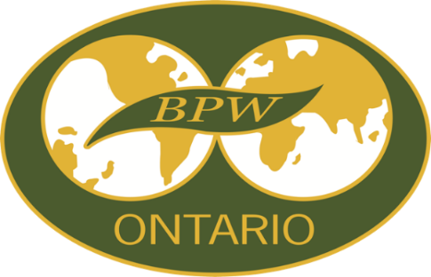

**BPW Ontario**

**Golden Horseshoe and Southwest Districts**

**Networking Event**

**Hosted by BPW Brampton**

**Saturday, October 21, 2023**

## Borealis Grille & Bar

**4336 King St East**

**Kitchener, ON N2P 3W6**

**11:00 am to 2:30 pm**

**Agenda**

**Meet and Greet**

**Business Meeting**

**Luncheon (select and pay from menu)**

**Guest Speaker**

**50/50 Draw**

**Raffle**

**Seating is limited**

**RSVP** [**barbarahore@rogers.com**](mailto:barbarahore@rogers.com) **by October 13, 2023**

**Barbara Hore**

**BPW District Director**

**Golden Horseshoe and Southwest Districts**

**barbarahore@rogers.com**